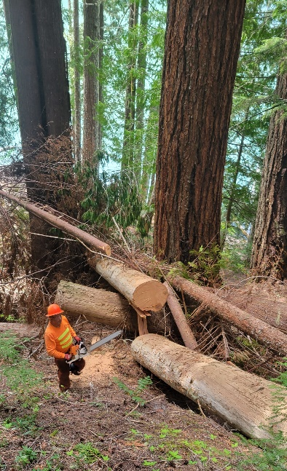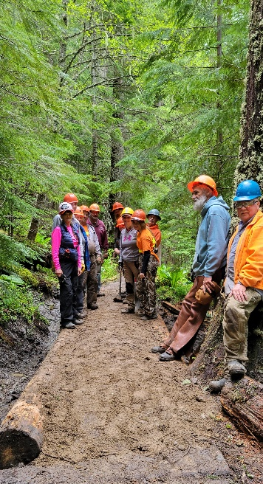

**BACK COUNTRY HORSEMEN OF WASHINGTON**

**LEWIS COUNTY CHAPTER**

**REGIONAL WORK PARTY /GIFFORD PINCHOT FOREST**

**PACKWOOD LAKE / MAY 1ST-4TH 2025**

**PRE-REGISTER ON-LINE AT BCHW.ORG**

**FOR MORE INFORMATION CONTACT TONY KARNISS @ 360-520-5697 OR** [**TONYKARNISS@GMAIL.COM**](mailto:TONYKARNISS@GMAIL.COM)

We will need volunteers for bushing, loping, swamping, blowdown removal, tread work. Sawyers will be needed and crosscut saws will be used in the GOAT ROCKS Wilderness areas. Quads can be used to get as far as the Lake on the access road NF1260 and haul in supplies and walk from that location. The upper trail #78 Is hike or horseback only. There is a primitive camping area where horse trailers and quads can be parked for day use or overnight. A forest pass is required. Sawyers, please bring your PPE as required and all volunteers will need gloves and appropriate attire and tools for work. The is something for everyone to do and help out.