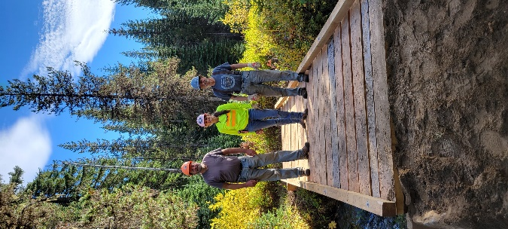 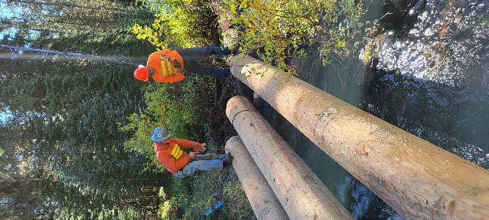

**BACK COUNTRY OF WASHINGTON**

**REGIONAL WORK PARTY – GIFFORD PINCHOT FOREST**

**KEENES HORSE CAMP**

**HOSTED BY – LEWIS COUNTY CHAPTER**

DATES – JUNE 15th-22nd 2025

**PRE- REGISTER AT BCHW.ORG.** THIS WILL HELP WITH FOOD SUPPLIES AND LET US KNOW HOW MUCH HELP WE HAVE COMING. THERE IS OVER NIGHT CAMP AREAS AND HORSE WATER. WE ARE PLANNING TO HAVE A GRAVEL HAUL AND GENERAL TRAIL MAINTENANCE,

**BUILDING AND A ONE DAY DEMONSTRATION ON TURNPIKE BUILDING**.

THERE IS SOMETHING FOR EVERYONE TO DO. JUST GETTING THE BRIDGE MATERIAL TO ITS LOCATION WE BE A BIG JOB. WE NEED VOLONTEERS FOR CAMP AND TRAIL WORK. TASK ARE: BRUSHING /SWAMPING, BLOWDOWNS REMOVEAL, SAWYERS WILL BE NEEDED. BRING GLOVES, TOOLS AND APPROVRIATE ATTIRE FOR THE JOB AND PPE. SAWYERS WILL NEED TO BRING THIER OWN PPE FOR SAWYER WORK. PACK STOCK IS NEED TO GET SUPPIES AND TOOOLS TO JOB LOCATIONS.